### Dr. AMBEDKAR INSTITUTE OF TECHNOLOGY

Near Jnana Bharathi Campus, Bengaluru-560 056.

(An Autonomous Institution, Aided by Government of Karnataka)



##### A Mini-Project Synopsis

##### on

**“PC AUTOMATION USING IR REMOTE CONTROL”**

Submitted By

**TEJAS M N TRISHUL VISHNU K T**

**1DA19CS179 1DA19CS181**

# Under the Guidance

# Of

**Dr. GOWRISHANKAR S**

**Professor, Dept. of CSE, Dr. AIT**

Department of Computer Science & Engineering

**2021-2022**

# TABLE OF CONTENTS

|  |  |  |
| --- | --- | --- |
| **SL. NO** | **CONTENT** | **PAGE. NO** |
| 1 | **INTRODUCTION** | 1 |
| 2 | **LITERATURE REVIEW** | 2 |
| 3 | **OBJECTIVES** | 3 |
| 4 | **METHODOLOGY** | 4 |
| 5 | **REQUIREMENT SPECIFICATIONS** | 8 |
| 6 | **APPLICATION OF THE PROJECT** | 9 |

**Chapter 1**

**INTRODUCTION**

In today's world need of automation is become necessary not only to reduce human effort but also to utilize maximum of the technology and to do everything smartly and efficiently in order to reduce both energy and time consumption. The idea of PC automation basically deals with controlling the computer and applications in it through Infrared remote just like a TV which helps users to perform their tasks comfortably without any hassle. The remote control is a device used to control another device remotely, usually wirelessly. In home electronics, a remote control can be used to operate devices such as a TV set, DVD player, or any other home appliance. The same remote can be used to control personal computers also.

Although we have wireless mouse and keyboard for controlling the computer it is sometimes inconvenient and uncomfortable to use them for purposes like controlling audio/video while watching movies, controlling PowerPoint presentations etc. In our proposed system user need not remember shortcuts to operate applications and can perform operations like opening, closing, moving through files, copying, pasting and many more through a single click of button on the remote. Another benefit of the proposed project is that users can reuse their old IR remotes by mapping buttons to key strokes/functions that they require to perform. Thus using a remote to control pc is more convenient and offers more freedom of movement and comfort.

The proposed system uses IR sensor interfaced with Arduino. The IR sensor receives signals from the remote and decodes them into binary / hex code. A GUI application written in python interprets these hex codes via serial port which then maps these codes to keystrokes/functions that are performed by users for specific task using a library called pyautogui. Whenever a user presses the button on remote the keystroke/function assigned to that button is executed thus simulating user actions.

**Chapter 2**

**LITERATURE REVIEW**

In order to come up with the idea of the project and to identify various strategies and techniques used in the project, it was necessary to conduct a comprehensive literature search and a thorough review of existing work. We surveyed around 5 different research papers which are described below:

1. **IR Remote Control Signal Decoder for Home Automation by** Samiran Maiti, 2014**: This research paper** describes a design and implementation of an infrared (IR) remote control signal decoder which can be used for various home control applications.

<https://www.researchgate.net/publication/343054852_IR_Remote_Control_Signal_Decoder_For_Home_Automation>

1. Utilization of Serial Communication in Arduino by Osisiogu & Ukachi, 2015: This paper gives an overview of Arduino, serial communication and then briefly explains how Arduino utilizes such feature.

<https://www.researchgate.net/publication/327285060_Seminar_Paper_on_Serial_Communication>

1. Working Principle of Arduino and Using it as a Tool for Study and Research by Leo Louis, 2018: This paper explores the working principle and applications of an Arduino board. This paper provides a glimpse of type of Arduino boards, working principles, software implementation and their applications.

<https://www.researchgate.net/publication/326316390_Working_Principle_of_Arduino_and_Using_it_as_a_Tool_for_Study_and_Research>

1. Robotic process automation by Peter Hofmann, Caroline Samp & Nils Urbach, 2019: This paper focuses on Robotic process automation (RPA) which is a technology for centralized automation of business processes. RPA automates user interaction with graphical user interfaces. <https://www.researchgate.net/publication/336769927_Robotic_Process_Automation>
2. Arduino Based Control And Data Acquisition System Using Python Graphical User Interface (GUI) by [Farid Khan](https://www.researchgate.net/profile/Farid-Khan-4), [Ahmad Masood](https://www.researchgate.net/profile/Ahmad-Masood-2) & [Atal Khattak](https://www.researchgate.net/scientific-contributions/Atal-Khattak-2101636880), 2021: This paper presents the development of a control and data acquisition system for a machines and equipments.Tkinter toolbox in Python language libraries is used to create the

GUI, while Arduino acts as intermediary between the system and the computer.

<https://www.researchgate.net/publication/352786556_Arduino_Based_Control_And_Data_Acquisition_System_Using_Python_Graphical_User_Interface_GUI>

**Chapter 3**

**OBJECTIVES**

The major objectives of the proposed project are:

1. To study and understand the working of IR Remote Control and its applications.
2. To design and implement IR Remote control to control Computer tasks.
3. To automate user task that require more than one operations to perform a single task.
4. To effectively reuse and utilize old IR remotes.
5. To cut down the hassle of controlling computer applications by far distances.
6. To develop a low cost user friendly application to remotely control applications on computer.

**Chapter 4**

**METHODOLOGY**

The IR remote is generally used in home theatres and is based on the principle of using infrared light as the medium of communication. A TV remote consists of a set of buttons and a circuit board. Each button is embedded with a black conductive disk which acts as a contact between the buttons and the printed circuit board. The circuit board or the chip consists of circuitry to sense the connections or detect the button being pressed and produces the signal in Morse code form which is amplified by the transistors and then given to IR LED. The IR LED is connected to the end of the circuit board and emits infrared light which is sensed by the sensor placed at the receiver of the TV.

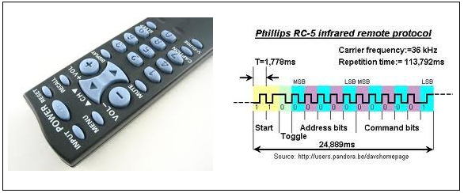

Today’s modern remote controls work by modulating the output from an infra-red LED. A series of pulses usually 10-20 pulses of varying width are sent to a gate that turns on or off, the modulator which is usually 38 kHz. The reason for modulation is to separate the remote IR range from the IR light emitted by other bodies in the vicinity. Usually, it requires a line of sight communication. When a button is pressed, the corresponding circuitry gets connected to bias the IR LED which emits IR light which contains the input. This output in the form of light pulses is pulse width modulated at 38 kHz frequency, which is obtained at the receiver by demodulation.

In the receiver, there is a tone decoder, which responds well to whatever signals the remote sends at a carrier frequency of 38 kHz. The microprocessor decodes the series of pulses and determines whether it is valid and if it is, will respond to that function.

**TSOP IR RECEIVER**

TSOP1738 is an IR receiver with an amplifier that acts as a switch and converter within a circuit. The basic purpose of TSOP1738 is to convert the IR signal to electric signals. Every IR receiver has a special frequency to operate. TSOP1738 operates on 38KHz IR frequency. In case of higher or lower frequency, it may act due to a current leakage or some other errors but it won’t fully operate. It uses silicon-based technology, which works at the microlevel and very sensitive and efficient to its functions. In summary, TSOP may be smaller in size but its usage with microcontroller and microprocessors makes it smart and secure. TSOP1838 is an improved version of TSOP1738.

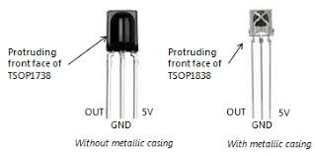 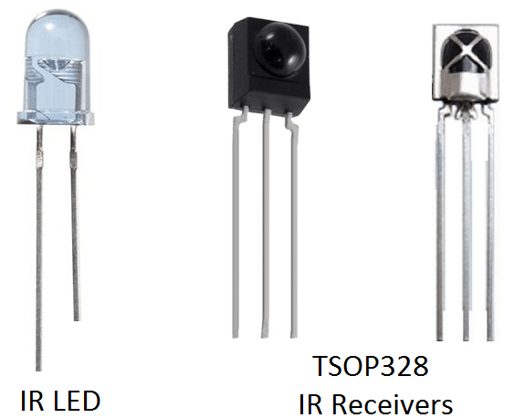

When the IR remote is pressed it sends out IR radiation. The TSOP1738 detects the IR which is switching on and off at the rate of 38Khz. TSOP’s output is active low, means its output will continue to remain HIGH when there is no IR, and becomes low when it detects IR radiation. So as to eliminate interference, the TSOP1738 operates at a particular frequency so that other IRs in the environment can’t interfere, except the modulated IR of particular frequency.

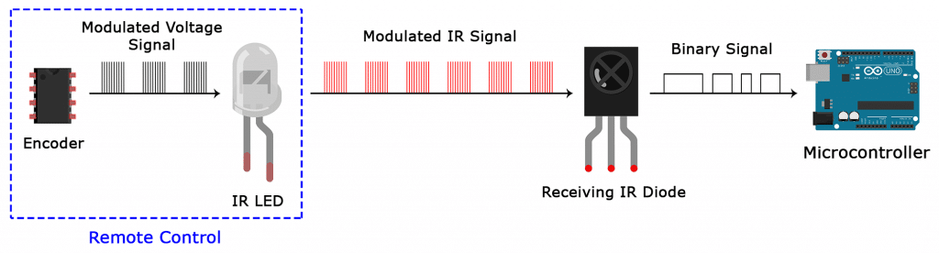

**ARDUINO UNO**

The Arduino Uno is an open source microcontroller board based on the Microchip ATmega328P microcontroller and developed by Arduino company.

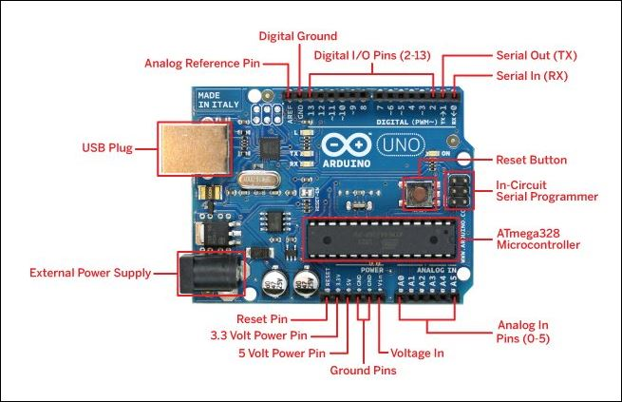

**CONNECTING TSOP 1838 IR RECEIVER TO ARDUINO**

Connect the signal pin (first from left) on tsop 1838/1738 to digital pin 4 of arduino, gnd pin (middle one) of tsop to digital pin 3 of arduino and vcc pin (right extreme) of tsop to digital pin 2 of arduino.

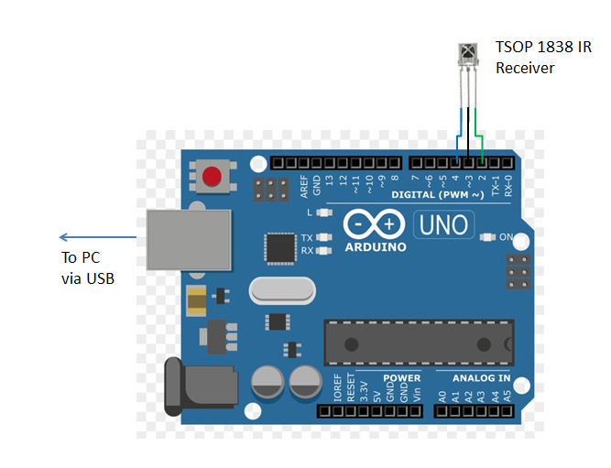

**WORKING OF THE PROJECT**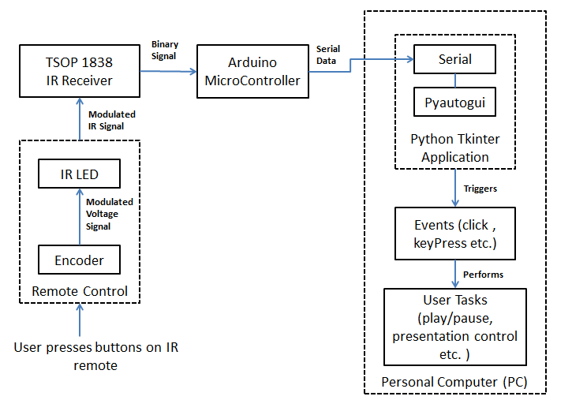

When any button of the IR Remote is pressed, the remote sends a code in form of train of encoded pulses using 38Khz modulating frequency. These pulses are received by TSOP1838 sensor and read by Arduino and then Arduino decodes received train of pulse into a hex/bin value and in turn will display it on the serial monitor.

Once you run the Python program a GUI application designed using tkinter opens prompting for the serial port through which it communicates to Arduino. Once you establish connection.

Arduino continuously monitors the infrared receivers. Once the signal from remote is received by Arduino The python program fetches these codes through serial communication using serial module and assigns specific functions which will be simulate events like mouse click , keypress etc using the pyautogui module that performs particular task like controlling volume , play/pause, presentation etc.

**Chapter 5**

**REQUIREMENTS SPECIFICATION**

**FUNCTIONAL REQUIREMENTS**

* User should be able to map inputs to outputs
* User should be able to control pc within 10-20m distance
* User should be able to Control sequence of execution
* User should be able enter COM port no. to which the device is connected to
* The system need to display the key pressed and function performed

**NON-FUNCTIONAL REQUIREMENTS**

* Performance
* Portability
* Extensibility
* Reliability
* Compatibility

**HARDWARE REQUIREMENTS**

* **Processor:** Intel i7 10th Gen
* **Processor Speed:** 2.4 GHz
* **Ram:** 8 Gb
* **Hard Disk:** 10 Gb
* **Microcontroller:** Arduino UNO
* **Others:** IR Remote, TSOP 1838 Receiver

**SOFTWARE REQUIREMENTS**

* **Operating System:** Windows 7/8/10/11
* **Integrated Development Environment:** Visual Studio Code, Arduino IDE
* **Language:** Arduino C/C++ with IR Remote Library, Python
* **Python Libraries:** serial, tkinter, pyautogui, threading

**Chapter 6**

**APPLICATIONS OF PROJECT**

Some of the applications of IR Remote Control are:

* Home Automation projects
* Home security systems
* Fire detection
* Proximity sensors
* Distance measurement
* Obstacle detection
* Infrared remote controlled toys

|  |  |
| --- | --- |
| **See related image detail** | **Dr. Ambedkar Institute of Technology** |
| **Department of Computer Science & Engineering** |

|  |  |
| --- | --- |
| Mini Project Batch-Id: | 2022-MP71 |
| Title of the Mini Project: | PC AUTOMATION USING IR REMOTE CONTROL |

**Details of Project Members**

|  |  |  |  |  |
| --- | --- | --- | --- | --- |
| Sl. No | USN | Name | Contact Number | E-mail Id |
| 1 | 1DA19CS179 | TEJAS M N | 7090570608 | [1da19cs179.cs@drait.edu.in](mailto:1da19cs179.cs@drait.edu.in) |
| 2 | 1DA19CS181 | TRISHUL VISHNU K T | 9535558871 | [1da19cs181.cs@drait.edu.in](mailto:1da19cs181.cs@drait.edu.in) |

|  |  |  |
| --- | --- | --- |
| Name of the Guide | Designation | Signature of the Guide |
| Dr. GOWRISHANKAR S | Professor, Dept. of CSE |  |

**Details of Guide**